**Part A**

**Instructions:  
1. If asked to create an iPhone app, create a separate project for that particular question.**

**2. You are not allowed to access the Internet at all. You may only use Apple documentation.**

**3. Each problem is worth 20 points.**

**4. For Q5, the table view should have two sections. Memorizing the code done in class will not help you in this assignment.**

**5. Good Luck!**

**Total marks: 150**

Q1. List some other technologies/frameworks other than Xcode, ObjectiveC and Swift that can be used to build iOS apps. [5]

Ans:

*Ionic with Cordova and Javascript, Xamarin with C# and .net, React Native*

Q2. In a playground file, create an array of tuples that contain a String, Int and Double. Using a for in loop, iterate through this array and print out each of the tuple elements separated by the string:  “~>” [5]

Q3. List the functions the implement the Application Life Cycle in no particular order. [10]

Ans:

willFinishLaunchingWithOptions

didFinishLaunchingWithOptions

applicationWillResignActive

applicationDidEnterBackground

applicationWillEnterForeground

applicationDidBecomeActive

applicationWillTerminate

**Or**

Difference between ARC and MRC. [10]

Q4. List the functions that implement the View Controller Life Cycle in no particular order.[10]

Ans:

viewDidLoad()

viewWillAppear()

viewDidAppear()

viewWillDisappear()

viewDidDisappear()

Q5. Create a simple iPhone app that can display a list of data items. The data items to be displayed on screen are a list of domestic and wild animals. The data should be displayed in appropriate sections. Tapping on a row should present an alert indicating the row number and section number of the tapped cell. [20]

Q6. Create a simple iPhone app that can access the Photo gallery on the simulator and display the selected image in an image view. The image view should have constraints to make it fit the entire screen and should have its display mode set to aspect fit. [20]

Q7. Which of the following incorrectly depicts MVC?[10]

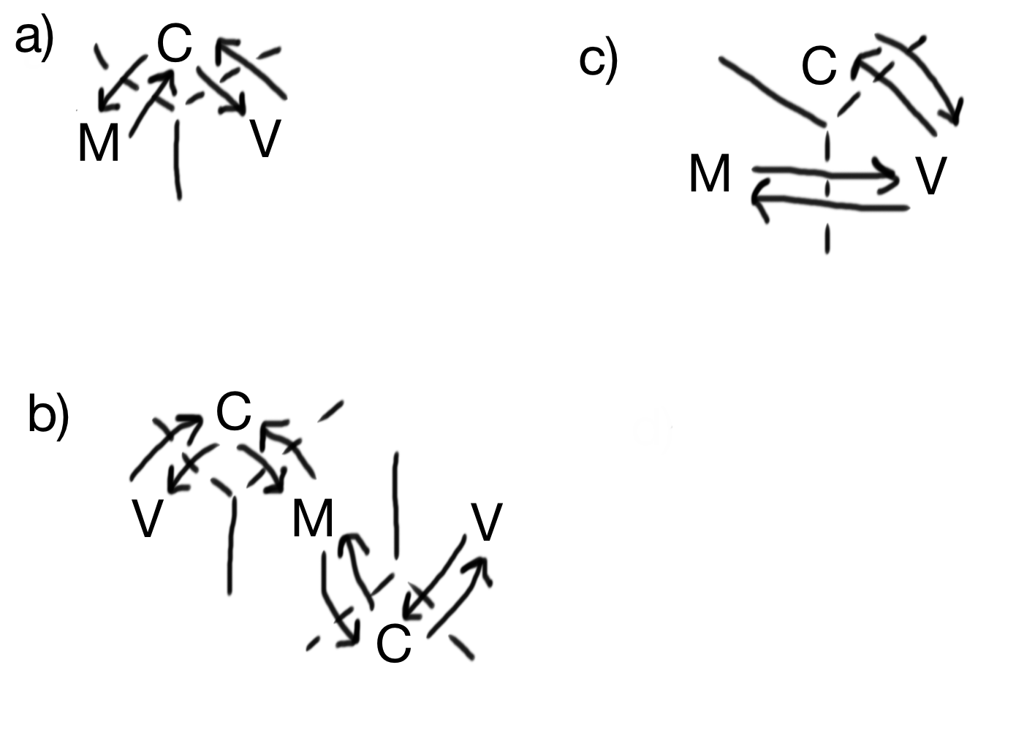

Ans: C

**Part B**

Q8. Create an application that will have three screens, On first screen you will have two button named “Present” and “Push”. When you click "Present" it should present a new VC and when you click "Push", it should navigate to a new screen. Make sure you should be able to come to first screen from pushed and presented view controllers. [20]

Q9. One struct and a class is written, out of 4 options provided choose the correct answer and write the reason for correct answer.[20]

struct Person {

var name: String

var age: Int

}

class Person1 {

var name: String

Var age: Int

}

a) let p1 = Person()

let p2 = Person1()

b) let p1 = Person(“RJT test”, 25)

let p2 = Person1()

c) let p1 = Person(name: “RJT test”, age: 25)

let p2 = Person1() //this line will gives error due no initializer inside the class

d) let p1 = Person(name: “RJT test”, age: 25)

let p2 = Person1(name: “RJT test1”, age: 25).

Ans: C

The reason I chose C is because of the way classes and structure behave. In a structure it is not necessary to explicitly write a init() function, but in class if you are not initializing variable/constants, it is compulsory to write init(). Since in the above example there is no init() in Class and the variables: name and age are not initialized; it will give an error.

Q10. Build an iOS app that is able to send information from one viewcontroller to another viewcontroller using segues. When a button is clicked on the first view controller, a segue should be initiated and the first view controller should send the current date to the next view controller. The second view controller should display this date in a label. [20]

Q->11 Write code to show difference between guard let, if let , guard else.[10]

Ans:

func test(){

let num1: Int? = 10

guard let num = num1

else {

print("test")

return // necessary to Return

}

print(num) // You can access the constant outside the scope

}

func test1(){

let num2: Int? = 10

if let num = num2

else {

print("test")

}

print(num) // You CANT access the constant outside the scope. Will get an error

}